Standard Flood Panel – The ILC Dover Flex-Cover®

GENERAL DESCRIPTION
The Flex-Cover® (also referenced as Flex-Cover D or FCD) is a high strength, water-tight, deployable barrier for use in flood protection of property and equipment. The system is designed to comply with the requirements of the International Building Code by meeting the design standards of ASCE 24-14 and ASCE 7-16. The barrier is comprised of an aluminum structural frame and a water barrier layer combined with high strength, highly engineered structural impact layers comprised of tensioned webbings and a fabric layer. The Flex-Cover® D system consists of panels of various sizes that may be stacked to meet the needs of the property owner/operator.

The Flex-Cover® D panels are stored off-site at a location determined by the owner and are deployed by moving to their point of use and bolted to pre-installed anchors in the building/structure following the methods described in this manual. It is important to follow the deployment procedure described in the O&M Manual to ensure the proper compression of all sealing gaskets, and to ensure that the seals are not damaged during storage, transit from the point of storage to the door opening, and during deployment.

To ensure proper compression of the bottom gasket on the Flex-Cover® versions, a downward compression feature is included on each side of the frame that enables a watertight seal to be created on the horizontal/ground surface. In addition, due to the vulnerable location of the bottom sealing gasket during transport and storage, the Flex-Cover® versions also include a gasket protection feature that automatically deploys to protect the bottom gasket from damage once the barrier is removed from position. Ensure this feature is utilized exactly as detailed herein. Damage to the seal will cause water leakage rates to be higher than advertised.

The Flex-Cover® can seal against most standard building façades, including concrete, brick, and CMU with some preparation. It is imperative however, as with any Dry Flood Proofing method, that the exterior walls be waterproofed so that flood waters cannot bypass the Flex-Cover® flood protection through the walls of the structure.

A foundation anchor kit is available for purchase from the distributor. Installed anchors will require installation prior to deployment using an anchor location template to position the wall foundation anchors in their proper locations and should be done by a qualified professional.

Robust Materials
The Flex-Cover® is manufactured from high-quality industry standard materials. All metal components are made from Aluminum for maximum environmental resistance and low weight. All composite and textile and membrane materials are highly durable and have been proven in long term use in other industries including aerospace, building coverings, trucking, and oil & gas production.

Patent US 9,598,851

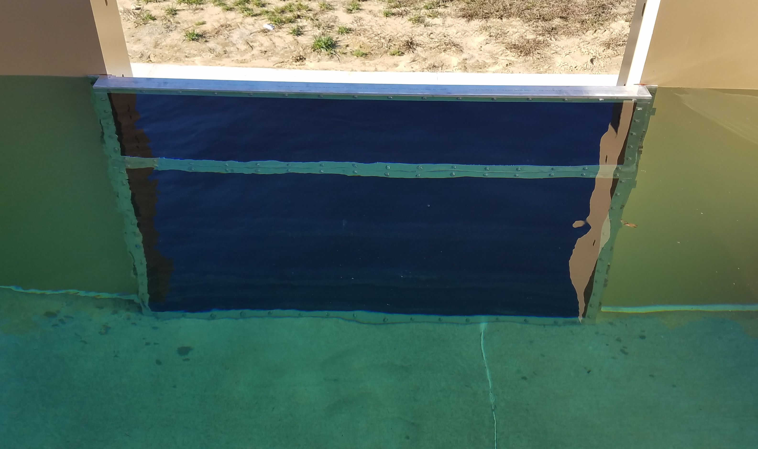
Stacked Panel (4’ and 2’) Leakage Testing

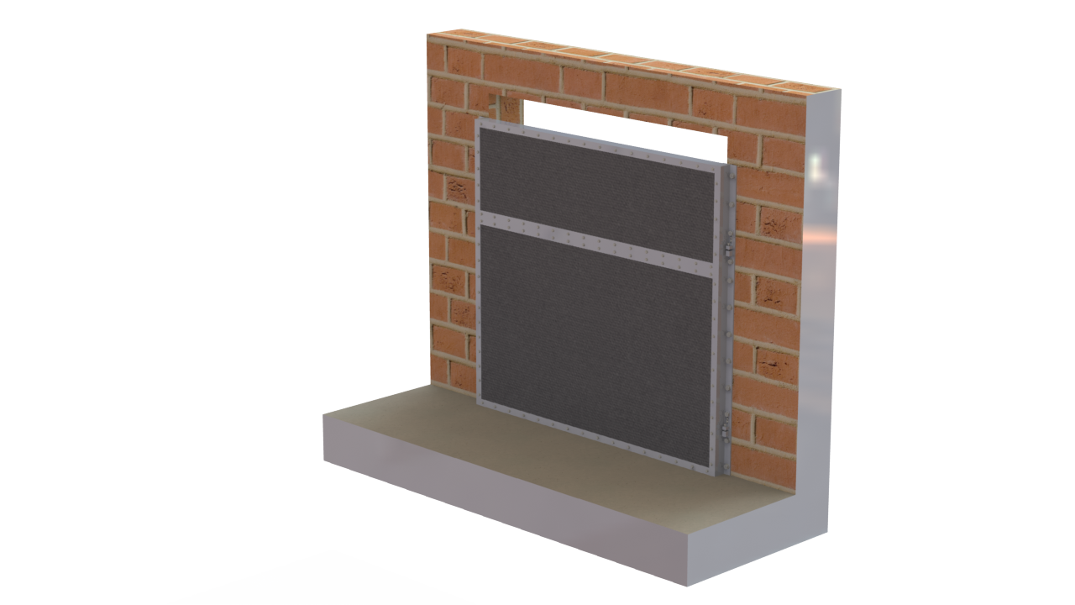
2ft high Flex-Cover® D
(Can be used independently for protection from <2ft of water)
4ft high Flex-Cover® D
Flex-Cover® D is stackable for protection up to 6ft of water
Cover-to-Cover Water Seal
(Same as sealing against the ground)

CONFIGURATIONS

The Flex-Cover® can be configured to protect many types of vertical openings. This includes doors, windows, ventilation openings, etc.

1.1. SCOPE. This section covers the Flex-Cover® for doors.

1.2. GENERAL. The equipment provided under this section shall be fabricated, assembled, erected, and
placed in proper operating condition in full conformity with the drawings, specifications, engineering data,
instructions and recommendations of the equipment manufacturer unless exceptions are noted by the
engineer. The Flex-Cover® shall be supplied with all the necessary parts and accessories indicated on the drawings, specified or otherwise required for a complete, properly operating installation, and shall be the latest product of a manufacturer regularly engaged in the production flexible flood barriers. The flood barrier supplied under this section shall be Flex-Cover® as manufactured by ILC Dover LP.

Robust Materials
The Flex-Cover® D is manufactured from high-quality industry standard materials. All textile and membrane materials are highly durable and have been proven in long-term use in other industries including building coverings, trucking, and oil & gas production. These include:

- A structural aluminum frame with an outer bladder layer, coated fabric water barrier and structural webbings,
- The outer bladder is a coated polyester fabric,
- The water barrier is vinyl coated polyester,
- The structural webbings are nylon
- Replaceable flexible seals on rear and bottom faces are closed cell silicone rubber,

Configurations
The Flex-Cover® D panels come in two standard heights and two standard widths. The different door configurations are designed to seal along the vertical wall on either side of an opening and the bottom seals along the horizontal surface/floor in front of the opening. An additional feature of the Flex-Cover® D configurations is that a 2ft high panel can be stacked on top of a 4ft high panel to provide up to 6ft of protection.

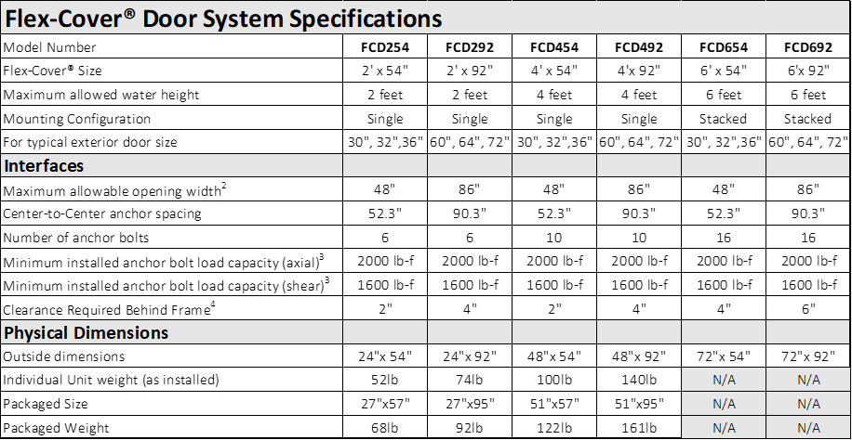

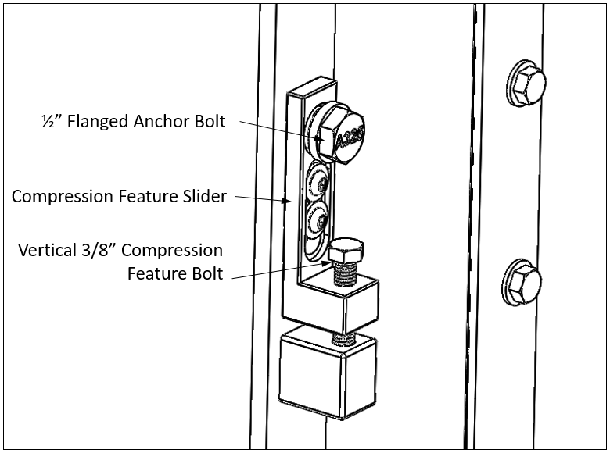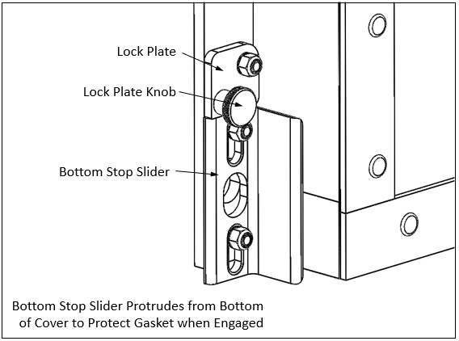

Flex-Cover® D Clamping and Gasket Protection Feature Details

1.3. QUALITY ASSURANCE

    - Manufacturer qualifications:
      - ILC Dover has a minimum of ten (10) years of successful experience in the design and manufacturing of tensioned fabric structures
      - ILC Dover has over one hundred (100) flexible, flood barrier systems installed
      - ILC Dover is ISO 9001 certified
      - ILC Dover is a Factory Mutual (FM) Approved supplier for Flood Barrier products
      - ILC Dover has a minimum of one (1) full time employee who is a registered Professional Engineer (PE) and a Certified Flood Plain Manager (CFM) through the Association of State Flood Plain Managers (ASFPM).

  - APPLICABLE CODES, STANDARDS AND SPECIFICATIONS

    - ASTM B 209 - Standard Specification for Aluminum and Aluminum-Alloy Sheet and Plate.

    - ASTM B 211 - Standard Specification for Aluminum and Aluminum-Alloy Rolled or Cold Finished Bar, Rod, and Wire.

    - ASTM B 221 – Standard Specification for Aluminum and Aluminum-Alloy Extruded Bars, Rods, Wire, Profiles, and Tubes

    - Aluminum Association - Specification for Aluminum Structures, 7th Edition.

    - FEMA P-936 – Floodproofing Non-Residential Buildings

    - ASCE 24-14 – Flood Resistant Design and Construction

    - SEI/ASCE 7-10 - Minimum Design Loads for Buildings and Other Structures.

    - ANSI/FM 2510 – American National Standard for Flood Abatement Equipment for Openings

2. PERFORMANCE

2.1. LEAKAGE. The Flex-Cover® shall be substantially watertight under the design head conditions. Leakage shall not exceed 0.08 U.S. gallon per hour per foot of periphery for the rated head as tested per ANSI/2510.

2.2. DESIGN HEAD. For the purpose of these specifications, the Flex-Cover® shall be defined as meeting the structural and leakage requirements at maximum water level.

2.3. Impact Resistance. The Flex-Cover® shall maintain the leakage level stated in Section 2.1 after an impact of 600 Joules as tested per ANSI/2510.

3. PRODUCT
  - Acceptable Manufacturers. The Flex-Cover® is manufactured by ILC Dover LP, Frederica, DE.
  - Acceptable Distributors. Floodproofing.com 800-507-0865 430 Andbro Drive Unit 1 Pitman NJ 08071 info@floodproofing.com
  - Structural Aluminum. Structural Aluminum for the frame assembly shall conform to ASTM standards.
  - Components. All material for fabric, stiffeners, hardware, gaskets, opening and closure mechanisms, and embedded frame pieces shall be selected and supplied by the manufacturer based on the submitted design calculations to meet the design loads and performance criteria. In addition to these requirements, the barriers shall have a 25-year service life. All components that will need to be replaced within this life span shall be identified and a replacement procedure submitted for review and approval.
  - Design. The Flex-Cover® shall be designed with a minimum 2:1 factor of safety based on material yield.

4. EXECUTION

4.1. INSTALLATION. The Flex-Cover® shall be handled and installed in accordance with the manufacturer's recommendations.

    - The manufacturer shall supply all components of the Flex-Cover® to be installed by the Contractor. Contractor shall coordinate the location of these components with all required project trades and submit a composite shop drawing for review and approval.
    - Barrier calculations and fabrication drawings can be submitted for review prior to the construction of the supporting frame; however, the final barrier dimensions and fabrication must be based on an as-built survey of the constructed frame to ensure proper size, fit-up, and closure.

    - If required by the end Client’s Contract, the Contractor shall conduct a full-size test on one pre-engineered Flex-Cover® similar to what will be installed on the project using the design loading criteria similar to the project.
    - The barrier selected for testing should be representative of the most common conditions present in the final design.
    - If no testing is required by the Client’s Contract, a Test Report from the Manufacturer can be provided for a configuration that is representative of the most common conditions present in the final design.
    - It is acceptable to conduct the test at the project site using similar boundary conditions.
    - The test leakage rate must be less than or equal to 0.08 U.S. gallon per hour per foot of periphery.
    - Verify proper deployment & removal after product installation.

5. WARRANTY

5.1 WARRANTY. Provide manufacturer’s warranty agreeing to repair or replace components of the Flex-Cover® water barriers in the event of defective material or substandard workmanship within 1 year from the date of Substantial Completion.

Customer Service: 1-800-507-0865 info@floodproofing.com

