INPRO-71200

flex-wall™ (Side Deployed)

Operations & Maintenance Manual

Version – Initial Release

Date: 9/22/2016

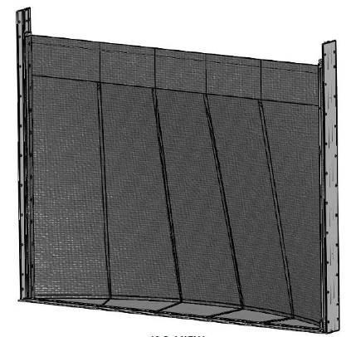

**ILC Dover LP – One Moonwalker Rd. Frederica, DE 19946 - www.ilcdover.com**

VERSION HISTORY

|  |  |  |
| --- | --- | --- |
| **Version #** | **Revision**  **Date** | **Reason** |
| IR | 9-22-16 | Initial Release |
|  |  |  |
|  |  |  |
|  |  |  |

**General information**

In these operating instructions, this symbol indicates points of particular importance to safety. The instructions at these points must always be observed in order to avoid the risk of serious injury.



TABLE OF CONTENTS

1 introduction 4

2 System Description 4

2.1 SIDE DEPLOYED Flex-Wall™ System Description 4

2.1.1 Type A Flex-Wall™ 7

2.1.2 Type B Flex-Wall™ 7

2.1.3 Type C Flex-Wall™ 8

2.1.4 Product Configuration Variations 8

2.2 Cautions 9

3 Flex-Wall™ Operation 11

3.1 Type A Flex-Wall™ operation 11

3.1.1 Type A Flex-Wall™ Deployment 11

3.1.2 Type A Flex-Wall™ Stowing 17

3.2 Type B Flex-Wall™ Operation 19

3.2.1 Type B Flex-Wall™ Deployment 19

3.2.2 Type B Flex-Wall™ Stowing 19

3.3 Type C Flex-Wall™ Operation 20

3.3.1 Type C Flex-Wall™ Deployment 20

3.3.2 Type C Flex-Wall™ Stowing 20

4 Flex-Wall™ Maintenance 20

5 Service Information 22

6 Warranty 23

7 Contact Information 23

# introduction

This document, the ‘Flex-Wall™ (Side Deployed) Operations and Maintenance Manual’, provides the information and procedures required for the proper storage, deployment, stowing, inspection and maintenance of installed Side Deployed Flex-Wall™ flood mitigation systems. The manual covers multiple Side Deployed Flex-Wall™ system configurations. The different configurations are identified by their ‘Type’. The manual is written to provide the owner and/or operators the detailed information required to properly use and maintain all of the Type systems that they may have installed.

# System Description

## SIDE DEPLOYED Flex-Wall™ System Description

The Side Deployed Flex-Wall™ is a flood mitigation system that is integrated with or attached to the adjacent infrastructure of an area requiring protection. The system is manually reconfigured to transition between the stowed and deployed configurations. When stowed, the Flex-Wall™ system is an unobtrusive part of the surrounding infrastructure adjacent to the area requiring protection. When deployed, the Flex-Wall™ inhibits water from entering the protected area.

There are multiple Side Deployed Flex-Wall™ configurations that are generally identified by ‘Type’. These different Flex-Wall™ Types allow accommodating various entryway, wall, perimeter and opening configurations that are defined by the specific location physical layout and protection requirements. The different Types utilize the same basic parts and attachments. In conjunction with the Type configuration selected components are tailored to fit the location size and interface requirements.

Side Deployed Flex-Wall™ system major parts are:

* a strong, flexible multi-layer flexible wall (coated fabric water barrier layer and textile webbing structural layer) that, when deployed, prevents the passage of water
* a “skirt” that is attached to the bottom of the multi-layered wall but lays flat against the ground, and contains a means of sealing to the ground (weighting or clamping plates with bolts)
* a container that houses the flexible wall and intermediate posts (Type B or C) when they are not in use, and packing cover for the flexible wall
* a receiver that is anchored to the building opposite the container, relative to the area of protection
* depending on the Flex-Wall™ Type and size, as needed pre-installed ground anchors may be required for intermediate posts or clamping plate sealing systems installation.
* a cable and tensioning system may be used in some situations to simplify deployment and retraction (similar to a shower curtain).

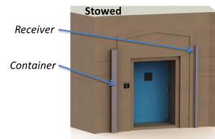 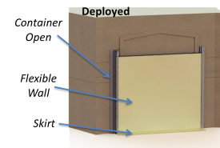

Flex-Wall System Components

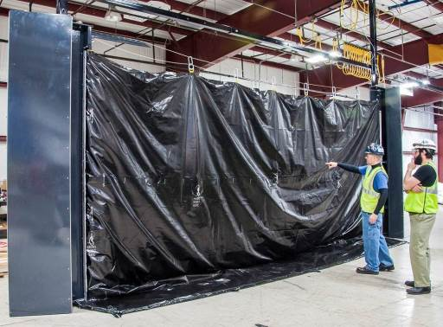

Flex-Wall deployed in factory (water side shown) – Note the tensioning cable and hanging clips at the top

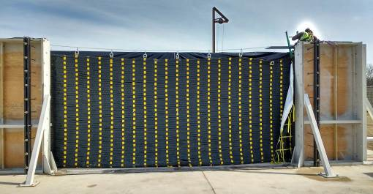

Flex-Wall deployed during factory test (dry side shown) – note the packing cover on the right side after deployment

The following sections describe the different Type of Flex-Wall™ systems and the site location configurations where they are used. The configurations are sometimes combined to create various protection systems and therefore multiple sections of this manual may be required to deploy and stow various systems.

|  |  |  |
| --- | --- | --- |
| **Situation** | **Type** | **Note** |
| Personnel Door(s) | A | Smaller opening widths |
| Vehicular entrance | A or B | Depends on opening width |
| Glass Store Front | B or C | Depends on property lines |
| Emergency Egress Point | C | Rescue location for stairs |
| Equipment (critical equipment) | C | Could be a stand-alone system |

Examples of how Types are applied

The appropriate configuration is determined by a combination of the installation site opening span, expected water load and personnel egress requirements. Each Flex-Wall™ is customized to fit and interface with its installation site.

### Type A Flex-Wall™

The Type A Side Deployed Flex-Wall™ system configuration is shown below. This configuration is installed in openings where the stowed barrier is able to span from the stowage container to the opposite side anchoring interface without needing intermediate vertical supports.

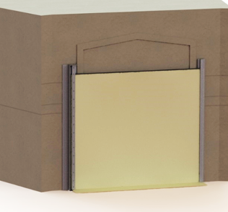

**Type A**

(Flex-Wall™ covers opening)

### Type B Flex-Wall™

The Type B Side Deployed Flex-Wall™ system configuration is shown below. This configuration is installed in openings where the stowed barrier requires additional vertical support(s) between the stowage container and the opposite side anchoring interface.

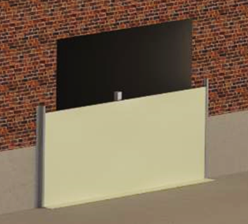

**Type B**

(Flex-Wall™ covers opening and uses intermediate posts)

### Type C Flex-Wall™

The Type C Side Deployed Flex-Wall™ system configuration is shown in Figure 2.3. This configuration is installed in openings where the stowed barrier requires additional vertical support-posts to create a ‘dry’ space outside the protected structure. The dry space is used to facilitate egress from these entryways in flood conditions.

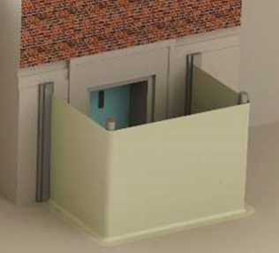

**Type C**

(Flex-Wall™ encloses an area through the use of intermediate posts)

### Product Configuration Variations

There are two configurations of skirt that offer a trade between speed of operation and leakage.

* + Clamped Skirt Configuration
    - Provides the best seal possible by compressing a gasket on the lower side of the Flex-Wall™
    - Requires installation of drop-in anchors along the skirt seal area during product installation
    - up to 0.01GPM/ft of opening perimeter
  + Weighted Skirt Configurations - up to 0.5GPM/ft of opening perimeter
    - Simple to operate – fast
    - Weighted Skirt Configurations - up to 0.5GPM/ft of opening perimeter

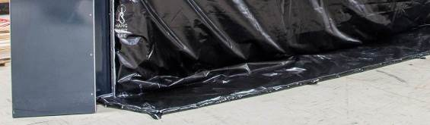

Weighted Skirt configuration (shot-bag weights in skirt)

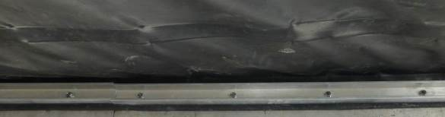

Clamped Skirt configuration (bolted to ground with clamping bars)

## Cautions

The following are precautions for the Flex-Wall™ system operation and maintenance. These are important to ensure the system operates as designed and personnel are not injured during the deployment or stowing of the system.

* 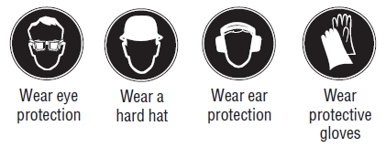Operation
  + We recommend the user and any other persons in the vicinity wear suitable eye protection, a hard hat, and protective gloves when deploying or retracting the Flex-Wall™.
  + Seepage – The Flex-Wall™ is designed to withstand flood water but will experience some seepage at its perimeter seals to the ground and building. The operator must consider some quantity of seepage and plan accordingly during the flooding event. The amount of seepage is dependent on building/grounds condition (cracks, scrapes), debris trapped in the opening during deployment (garbage, leaves, etc.), and proper deployment.
    - Clamped Skirt Configuration – up to 0.01GPM/ft of opening perimeter
    - Weighted Skirt Configurations - up to 0.5GPM/ft of opening perimeter
    - Sump systems must be used to mitigate seepage per code requirements in local areas. Ensure power (electric or battery back-up) will be available
  + Trip Hazards – The Flex-Wall™ skirt will lay on the ground and should be avoided as a walking surface or tripping may occur.
  + Tensioned Cable Hazards – When in use the tensioned cable which aids deployment must not be over tensioned or failure could occur.
  + Impact Deflection – The Flex-Wall™ is designed to withstand impact from floating debris as specified for its installation location. It should be noted that debris impact can cause deflection in the wall and therefore the distance between the wall and the building/entrance must be considered to avoid imparting impact loads to the building/entrance.
* Deployment and Retraction
  + Lifting Hazards – Proper precautions must be taken when lifting or pulling parts of the Flex-Wall™ in order to avoid injury.
  + Pinch Hazards - Proper precautions must be taken when clamping plates, closing doors, sliding cable clips and other actions in order to avoid injury.
  + Wind Effects - Proper precautions must be taken when deploying the Flex-Wall in wind in order to avoid injury. Care must be taken to avoid standing in locations where the wall or container door can catch wind swing.

# Flex-Wall™ Operation

## Type A Flex-Wall™ operation

The following sections describe the operation of the Type A Flex-Wall™.

### Type A Flex-Wall™ Deployment

These steps are for reconfiguring a Type A from a closed container to a deployed system.

STEP 1. Open the container and receiver cover (if covered) by unlocking (if required) the latches and opening them (this may require tamper resistant screw bits or keys for locks if used). Swing the doors open and temporarily secure them, or stow them, to avoid damage from wind.

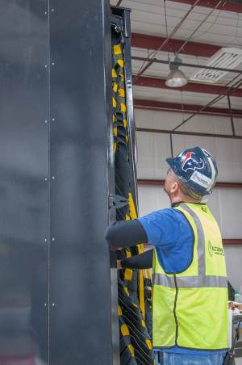 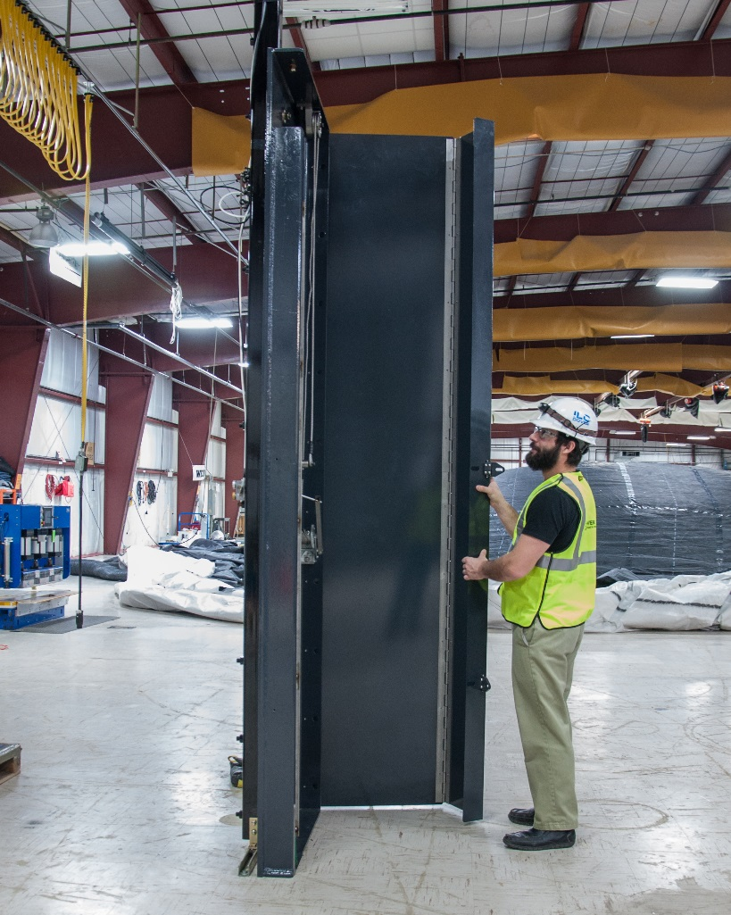

Opening the Flex-Wall Container (left) and Receiver (right)



*WARNING: Improper securing of container or receiver doors can lead to system damage or personnel safety issues.*

STEP 2. Release the Flex-Wall™ from the container by unlatching the ratchet straps on the packing cover (if used in your installation – some containers do not require a packing cover).

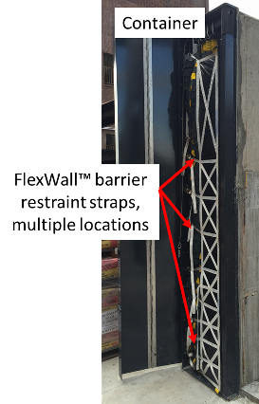 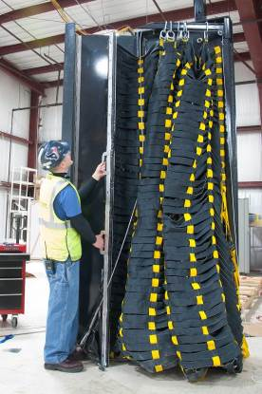

Typical Ratchet Strap Locations Positioning Swing Arm with the Anchor Bar

STEP 3. Rotate the wall support arm and Flex-Wall™ from inside the container (typically 180 degrees) to point towards the receiver (if the wall support arm is not fixed). The swing arm may be secured and require release by pulling the red cord to release the detent latch. The Flex-Wall™ will then be in the deploying position. The anchor bar should be towards the receiver side. Secure the packing container door in the open position and stow any container panel covers.

STEP 4. Connect the wire cable at the top of the container side to the wire cable in the receiver container.

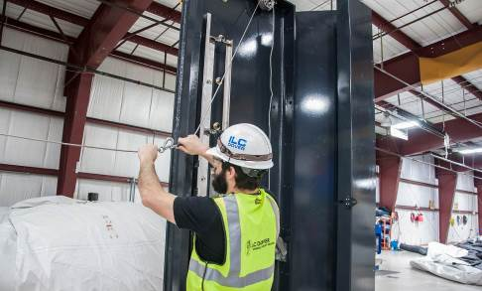

Tensioning Cable Connection

STEP 5. Tighten wire cable by turning the winch in the receiver container. The cable is positioned correctly when it bridges across the top of the containers and is taught (no sag).

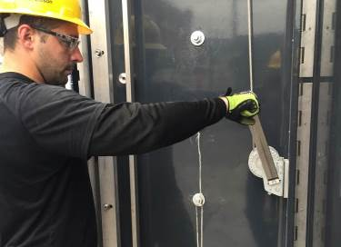

Tensioning the Support Cable



*WARNING: Do not overtighten the cable as failure may occur which could damage the system or endanger personnel.*

STEP 6. Deploy the Flex-Wall™. Pull the anchor bar and flexible wall across the cable moving from the packing container to the receiver container. Make sure the anchor bar is positioned as close to the receiver as possible (< 1ft away). The suspended skirt typically prevents the wall from being fully deployed at this step.

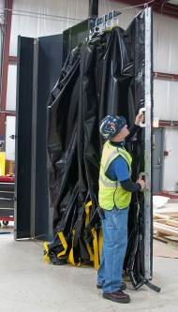 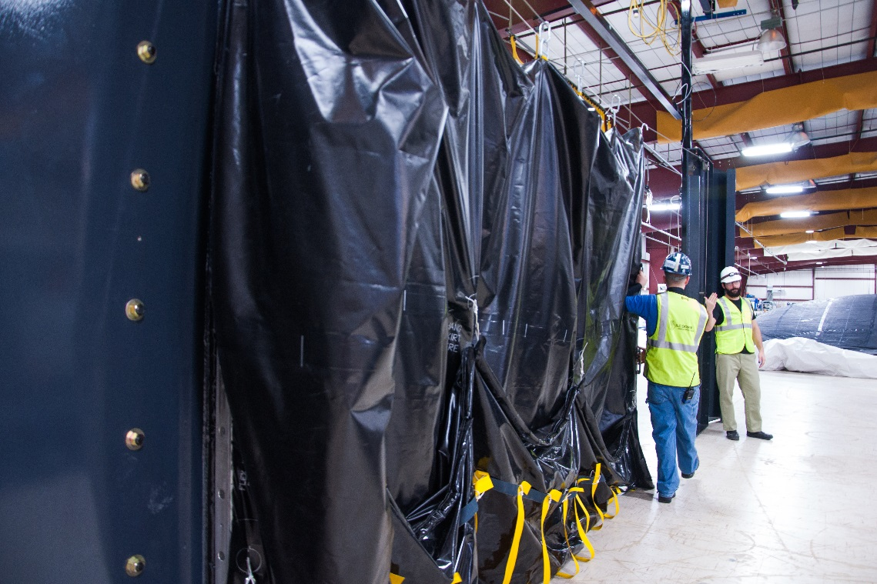

Deploying the Flexible wall

STEP 7. The Flex-Wall™ skirt is folded up and hangs on ‘S’ hooks. Unhook the skirt from its attachment points on the flexible wall. Lay the skirt flat on the ground. Pull the flexible wall and skirt into position in front of the clamping location in the receiver (fully deployed).

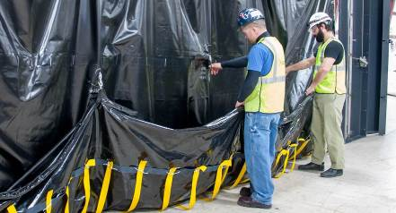

Unhook the Skirt from the Flexible Wall

STEP 8. Open the clamp bar in the receiver container. Lift the anchor bar from the wire cable. Position the bar inside the vertical channel in the receiver container. The anchor bar will be nested inside the receiver channel with the Flex-Wall™ barrier material interface facing out. Slide the bottom end of the anchor bar to the bottom of the receiver channel.

Note – Shorter walls will use a simpler clamping method. In this case, remove the bolts from the receiver plate and place the anchor bar over the positioning pins. Then thread and tighten the bolts to 38 ft-lbs torque for ½ in bolts to compress the gasket seal.

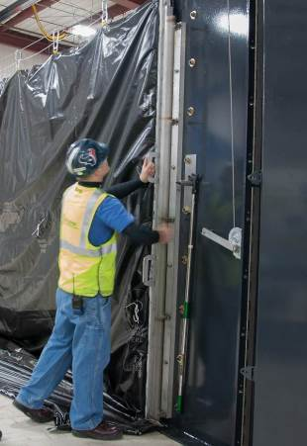 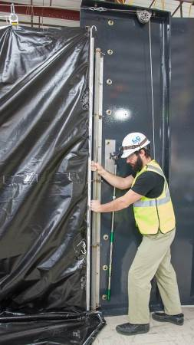

Anchor Bar Capture in Receiver Channel Clamping the Anchor Bar

STEP 9. Lock the anchor bar into place by rotating the bar attached to the clamps. The anchor bar attached to the barrier is now clamped into the receiver channel.

*WARNING: The metal bar must be completely down and seated in the bottom of the receiver container mechanism to minimize water leakage past the barrier.*

*WARNING: The Flex-Wall™ barrier material must not be captured between the anchor bar and the receiver channel. Damage to the fabric barrier and /or leakage may occur if the barrier material is pinched.*

*WARNING: All clamps must be in the completely closed position to ensure the anchor bar is properly secured.*

STEP 10. Position the skirt flat on the ground in front (water side) of the Flex-Wall™. The goal is to make its outer edge smooth against the ground to eliminate leak paths.

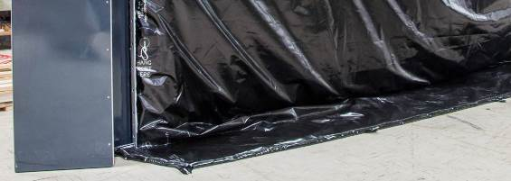

Skirt Positioning

STEP 11. [WEIGHTED SKIRT CONFIGURATION]. Once the skirt is in place, carefully walk on the embedded weight, along the edge of the skirt, to conform the skirt interface to the local ground surface.

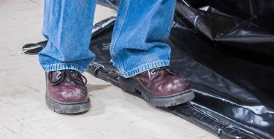

Skirt Conforming

STEP 11. [CLAMPED SKIRT CONFIGURATION]. Remove the anti-fowling covers or bolts in the pre-installed receivers in the ground along the skirt location. This may require tamperproof tool bits. Reposition the skirt. Once the skirt is in place, position the clamping plates on top of the skirt to align with the receivers and bolt them to the ground.

*WARNING: The clamping plates must be properly installed to ensure minimal leakage. The plates should be bolted and torqued to 38 ft-lbs torque for 12/in bolts.*

STEP 12. Secure all container doors and covers with latches. Inspect the system and verify that there are no gaps that may lead to leakage past the barrier.

### Type A Flex-Wall™ Stowing

These steps are for reconfiguring a Type A Flex-Wall™ from a deployed configuration to a stowed system. The user can determine if they want to stow the Flex-Wall immediately to reopen the facility, or if they want to clean and stow the Flex-Wall for future use. It is possible to stow the wall and reopen it for cleaning and re-stowing at a later date (night or weekend cleaning). The Flex-Wall™ should be cleaned as soon as possible to eliminate biological growth such as mold or fungus. Cleaning is only required if the Flex-Wall becomes exposed to water which might carry biologic matter (river water, seawater, storm water, etc.)

STEP 1. [WEIGHTED SKIRT VERSION] Clear water and debris off the skirt by moving the wall.

STEP 1. [CLAMPED SKIRT VERSION] Unbolt the clamping plates that hold the skirt to the ground. Stow the clamping plates in the container if they are not permanently attached to the skirt. Return the bolts or covers into the threaded receivers in the ground.

STEP 2. [CLAMPED VERSION] Unlock the anchor bar from the receiver by rotating the bar attached to the clamps.

Note – Shorter walls will use a simplified clamping system. In this case, unbolt the anchor bar from the wall and lift the anchor bar off the pins. Place the bolts back into the receiver.

STEP 3. Hang the skirt on the wall by using the S-hooks and hanging straps on the skirt.

STEP 4. Slide the Flex-Wall™ along the tensioned cable toward the container. Slide the hooks that hold the Flex-Wall onto the support arm. An extension hook is available in the receiver container to support this step if necessary.

STEP 5. Remove tension in the cable by releasing the winch and let the cable drape toward the ground. Disconnect the cable by releasing the in-line connector.

STEP 6. Stow the receiver side of the cable in the receiver. Retract the cable into the receiver container and attach the end to its anchor point in the container and use the winch to create some tension on the cable in the packed state. Note to keep tension on the cable during the winch process to ensure that the cable does not tangle. Close the receiver cover. Lock the cover if necessary.

STEP 7. If the support arm can swivel, rotate it into the container. If the support arm is fixed in its position move to the next step.

STEP 8. Fold the Flex-Wall™ so that it fits into the container. The folds will take a “Z” shape, and should be made as wide as the container. The tensioning cable will fit into the material however convenient. Note that the vertical webbings should serve as a guide for the ‘Z’ fold locations.

STEP 9. Place the packing cover over the Z-folded Flex-Wall™ (if a packing cover is used). Attach and tighten the ratchet straps to compress the wall into the container.

STEP 10. Close the container and lock the door if necessary.

**

*WARNING: If the container does not easily close then release the ratchet straps and return to STEP 8 to repack the wall to get the stack of material to be shorter.*

## Type B Flex-Wall™ Operation

The following sections are used for nominal reconfiguration of a Type B Flex-Wall™ between the stowed and deployed configurations.

### Type B Flex-Wall™ Deployment

These steps are for reconfiguring a Type B from a closed container to a deployed system.

Follow the Type A Flex-Wall™ deployment steps (3.1) with the following exceptions:

STEP 1A. Open the pre-installed anchor covers on the intermediate post anchoring positions. Move the intermediate post(s) to their anchoring position and bolt them in place.

STEP 4A. If required, attach cable to intermediate post (place in hook or eyelet). Use the extension hook from the receiver container, or a ladder if required.

STEP 6A. If the tensioned cable is connected to the intermediate post(s), then use the extension hook from the receiver box to lift and reattach the hooks to the tensioned cable to allow the wall to pass by the intermediate post cable support. Note: The extension hook is not required for shorter walls.

### Type B Flex-Wall™ Stowing

These steps are for reconfiguring a Type B Flex-Wall™ from a deployed configuration to a stowed system.

Follow the Type A Flex-Wall™ stowing steps (3.1) with the following exceptions:

STEP 4A. If the tensioned cable is connected to the intermediate post(s), then use the extension hook from the receiver box to lift and reattach the hooks to the tensioned cable to allow the wall to pass by the intermediate post cable support. Note: The extension hook is not required for shorter walls.

STEP 9A. Unbolt the intermediate post(s) and move them to their storage location in the container. Replace the pre-installed anchor covers on the intermediate post anchoring positions.

## Type C Flex-Wall™ Operation

The following sections are used for nominal reconfiguration of a Type C Flex-Wall™ between the stowed and deployed configurations.

### Type C Flex-Wall™ Deployment

These steps are for reconfiguring a Type C Flex-Wall™ from a closed container to a deployed system.

Type C deployment operations are identical to type B operations except that the Flex-Wall™ may have corners or angles.

### Type C Flex-Wall™ Stowing

These steps are for reconfiguring a Type C Flex-Wall™ from a deployed configuration to a stowed system.

Type C stowing operations are identical to type B operations except that the Flex-Wall™ may have corners or angles.

# Flex-Wall™ Maintenance

The following is a description of general maintenance required for the Side Deployed Flex-Wall™. Frequency of maintenance is at the discretion of the owner but ILC recommends that inspections be performed yearly (in some cases this is by code), and maintenance be performed at those inspections as required.

Mechanical Equipment:

* Operation: Inspect and lubricate rotating surfaces, then verify good working order.
  + Container & receiver cover latches and hinges.
  + Ratchet mechanism.
  + Clamping bar mechanisms.
  + Bolts, nuts, and covers [CLAMPING BAR SYSTEMS].

Gaskets and Flexible Materials:

* Operation: Inspect and repair damaged components as necessary.
  + Receiver gasket.
  + Skirt gasket [CLAMPED SKIRT CONFIGURATION ONLY].
  + Coated Fabric component of the Flex-Wall™ – look for holes or cuts. Notify ILC Dover to arrange repair if necessary.

Site Location:

* Operation: Inspect and repair building & ground surfaces
  + Building to container or receiver interface – look for cracks and fill any that are found.
  + Ground where skirt will seal – look for cracks and fill any that are found.

Cleaning after a storm is critical to maintaining longevity of the system. All biologic matter must be removed to prevent mold and fungus growth. The Flex-Wall™ can be stowed wet immediately after a flood so the facility can be opened if desired. However, the system must be cleaned as soon as possible to limit growth. This enables work to be conducted on night or weekend shifts. The following steps should be taken after exposure to flood water (river water, seawater, run-off, etc.):

* Deploy the system
* Spray the system with an environmentally friendly soap and water solution
* Rinse the system to remove soap. Power wash if necessary.
* Allow the system to dry
* Repack the system

# Service Information

As a guideline, the Side Deployed Flex-Wall™ is capable of 75 years of operation with proper routine maintenance and refurbishment of the flexible materials at planned intervals. Refurbishment intervals are dependent on operational use and environmental conditions. The limiting elements of any flood protection system are the elastomeric components (seals and coated fabrics). Our systems are designed to use the longest life materials available and protect these materials from environmental exposure when not in use.

We anticipate that the flexible components of the system will need to be replaced at 20-25 year intervals. ILC Dover will perform this service. No replacement of metallic components is anticipated for the life of the product.

Other fee-based services ILC can perform include:

* inspection of the Flex-Walls™ to aid in the assessment of materials life
* component replacement
* system test and evaluation
* operator training
* spare parts (extra parts to have on hand in case something is damaged or lost during training or operation)

# Warranty

Seller warrants to Buyer that the Goods at the time of shipment to Buyer hereunder, (a) will conform to the specifications of the order; (b) that it will convey good title thereto and that such Goods will be delivered free from any lawful security interest or other lien or encumbrance unknown to Buyer; and (c) that such Goods will be free from defects in material and workmanship. The warranty shall begin upon final acceptance and shall extend for a period of one (1) year. The warranty is contingent upon performance of servicing and maintenance of the deliverable as specified in the maintenance plan. If nonconforming work is identified within the warranty period, Buyer shall promptly notify Seller in writing and Seller, at Buyer’s option, shall promptly repair or replace the defective goods.

Notwithstanding any other provision contained herein or any other obligation of Buyer hereunder, Buyer, upon acceptance of Goods that are the subject of the Order, warrants that Buyer, its successors, assigns, agents and employees are industrial users of such Goods and possess the knowledge and expertise to use the same in accordance with (i) accepted industry standards, (ii) all applicable laws, (iii) prudent safety practices and (iv) operating manuals or other instructions provided by Seller, if any.

# Contact Information

ILC Dover

One Moonwalker Road

Frederica, Delaware 19946

Sales & Customer Service:

1-302-335-3911 x 506 or  
1-800-631-9567 (US Toll Free)

Email: customer_service@ilcdover.com

See more at: <http://www.ilcdover.com>