SECTION 10 71 19
FLOOD PROTECTION PERIMETER SYSTEM

** NOTE TO SPECIFIER ** Floodproofing.com
This section is based on the products of Floodprooing.com which is located at:
430 Andbro Dr. Unit 1
Pitman, NJ 08071
Tel: 800-507-0865
Email: info@floodproofing.com
Web: www.floodproofing.com
Floodproofing.com is a National Leader of manufacturing and distributing Floodproofing Products that meet FM Global Standards, ANSI, ASCE, and FEMA/ICC Building Codes..
Floodproofing.com has a complimentary Plans Review Division where a team of Certified Floodplain Managers and Engineers will customize a floodproofing layout on your plans, run a Flood Zone Determination, check compliance and potential flood insurance rates, and more. Get started today by sending your Flood Zone plans to plans@floodproofing.com.
- GENERAL
  - SECTION INCLUDES
** NOTE TO SPECIFIER ** Delete items below not required for project.
FLOOD PROTECTION PERIMETER SYSTEM
    - FLOOD PROTECTION PERIMETER SYSTEM – Manually deployable.
  - RELATED SECTIONS
    - N/A
** NOTE TO SPECIFIER ** Delete any sections below not relevant to this project; add others as required.
  - REFERENCES
** NOTE TO SPECIFIER ** Delete references from the list below that are not actually required by the text of the edited section.
    - ASCE/SEI 24-14, Flood Resistant Design and Construction.
    - ASCE/SEI 7-16, Minimum Design Loads and Associated Criteria for Buildings and Other Structures.
  - DESIGN / PERFORMANCE REQUIREMENTS
    - Diluvium Flood Protection Systems are engineered to comply with the following:
      - Certifications:
        - American National Standard for Flood Abatement Equipment ANSI/FM Approvals 2510 -2014.

  - SUBMITTALS
    - Submit under provisions of Section 01 30 00 - Administrative Requirements.
    - Product Data: Manufacturer's data sheets on each product to be used, including:
      - Preparation instructions and recommendations.
      - Storage and handling requirements and recommendations.
      - Installation methods.
    - Manufacturer's Certificates:
        - ISO 9001:2015 Manufacturer Quality System approval - Lloyds’s Register Certificate identity number: 10221103
    - Area plans and drawings: Area plan and perspective drawings necessary for correct placement, installation and operation for the complete flood barrier delivery.
    - Installation and Deployment: Documentation for installation, deployment, disassembly, cleaning and maintenance, and storage for each flood barrier segment to be installed.
  - QUALITY ASSURANCE
    - Manufacturer Qualifications: Company specializing in manufacturing products specified in this section with minimum 5 years documented experience.
    - Installer Qualifications: Installer with experience on projects of a similar size and scope with similar installation conditions.
  - DELIVERY, STORAGE, AND HANDLING
    - Components shall be without damage when delivered to site in reusable covers and shall be handled and stored in covers to prevent any damages to components.
    - Store products in clean, dry area indoors until ready for installation. Store materials in accordance with manufacturer's instructions.
    - Protect materials and outer finish from damage during handling and installation.
  - WARRANTY
    - Provide a copy of the manufacturer's standard warranty against manufacturing defects, with terms on conditions.
  - MAINTENANCE AND REPAIR
    - The system can be cleaned with a pressure washer (see manufacturer instruction for cleaning). Any local requirement for disposal of return water must be followed during cleaning.
    - The system can be repaired according to manufacturer’s instructions. A repair kit can be supplied from the manufacturer.
- PRODUCTS
  - MANUFACTURERS
    - Acceptable Manufacturer: Norwegian Weather Protection AS, which is located at: Rosslandsvegen 410; 5918 Frekahaug, Norway.; Tel: +47 56 35 64 00; Email: post@nwp.as; Web: www.nwp.as
** NOTE TO SPECIFIER ** Delete one of the following two paragraphs; coordinate with requirements of Division 1 section on product options and substitutions.
    - Substitutions: Not permitted.
    - Requests for substitutions will be considered in accordance with provisions of Section 012500
    - Approved North American Distributor: Floodproofing.com which is located at 19 Mantua Road Mount Royal, NJ 08061 800-507-0865 Plans@floodproofing.com
** NOTE TO SPECIFIER ** Edit the following paragraphs as required and applicable to project requirements. Select the type and the model required and delete those not required.
  - Design requirements:
    - Diluvium sections will be based on the flood elevation indicated in the drawings and manufactures standard section heights, with minimum height for required control of flood waters at the specific location of installation.
    - Manufacturer will design and fabricate the Diluvium sections using the standard sections height of 3’, 4’, 5’ and 6’, and standard section perimeter length of 10’. Special sections for corners and attachment to walls will be designed according to the drawings for each location.
    - The diluvium is constructed of light weight and strong materials like technical textiles and glass reinforced polymers and can be deployed and installed using manual labor with no need for extra tooling.
- DEPLOYMENT
  - PREPARATION
    - The area for the deployment shall be clean and free of debris that could damage or interfere with the function of the Diluvium sections.
    - Prepare surfaces for any cracks using the methods recommended by the manufacturer for achieving the best result for sealing between sections and ground.
  - INSTALLATION
    - Install in accordance with manufacturer's instructions.
    - Place each package with the Diluvium sections along the perimeter close to where they will be installed.
    - Unfold the sections according to the installation procedure, with the dry surface of the wall facing upwards and fold in the fabric facing towards the dry side.
    - Raise the wall and simultaneously lock the composite pipes on the steel wires to lock the wall in the upright position. Repeat step for the neighboring section.
    - Connect the zippers between two sections. Start by connecting the zipper closest to the ground. This is the load bearing zipper. Then connect the second zipper. This is the sealing zipper.
    - Repeat C to E for all the sections along the perimeter.
    - Connect any wall mount sections to the wall according to manufactures drawings and instructions. For bolting sections to a wall the wall must comply with the criteria in ASCE/SEI 7-16.

  - INSPECTION AND PROTECTION OF THE SECTIONS
    - The complete installation shall be inspected according to the Installation Checklist for all sections and attachment between sections and existing installations.
    - The Installation Checklist:
      - The side with steel wire support are facing towards the wet side.
      - All composite rods are in locked position
      - All wall mounts are done with correct bolts and all bolts are tighten
      - No damage to the fabric and the zippers
      - All zippers are completed closed and sliders are in locked position.
      - No damage to the steel wires or any open loops on the steel wires connection to the Eye nuts.
    - The sections should be checked for daily for any damages caused be vandalism by people or animals.

- MATERIALS OVERVIEW
  - Materials
    - All materials used in the Diluvium sections are selected for long time use in water and to be approved by the ANSI/FM Approval 2510. The materials are quality controlled according to the FM Approval requirements.
    - List of materials

No. | Material | Document
1 | PVC/PU coated polyester weave | Technical Data Sheet.
2 | G20 type zipper | Technical Data Sheet
3 | Zipper | Technical Data Sheet
4 | GRP pipes | Declaration of Conformity
5 | GRP supports | Declaration of Conformity
6 | Steel wires | Declaration of Conformity
7 | Crimp ferrules for steel wires | Declaration of Conformity
8 | M8 Eye-nuts | Declaration of Conformity
9 | M8 Steel bolts | Declaration of Conformity

- WALL MOUNT
  - Special sections for wall mount are available from manufacturer. These sections can be anchored to a wall with special concrete anchor bolt. The correct bolt for anchoring must be selected according to recommendation from the building constructor.
  - Drawing of wall mount section

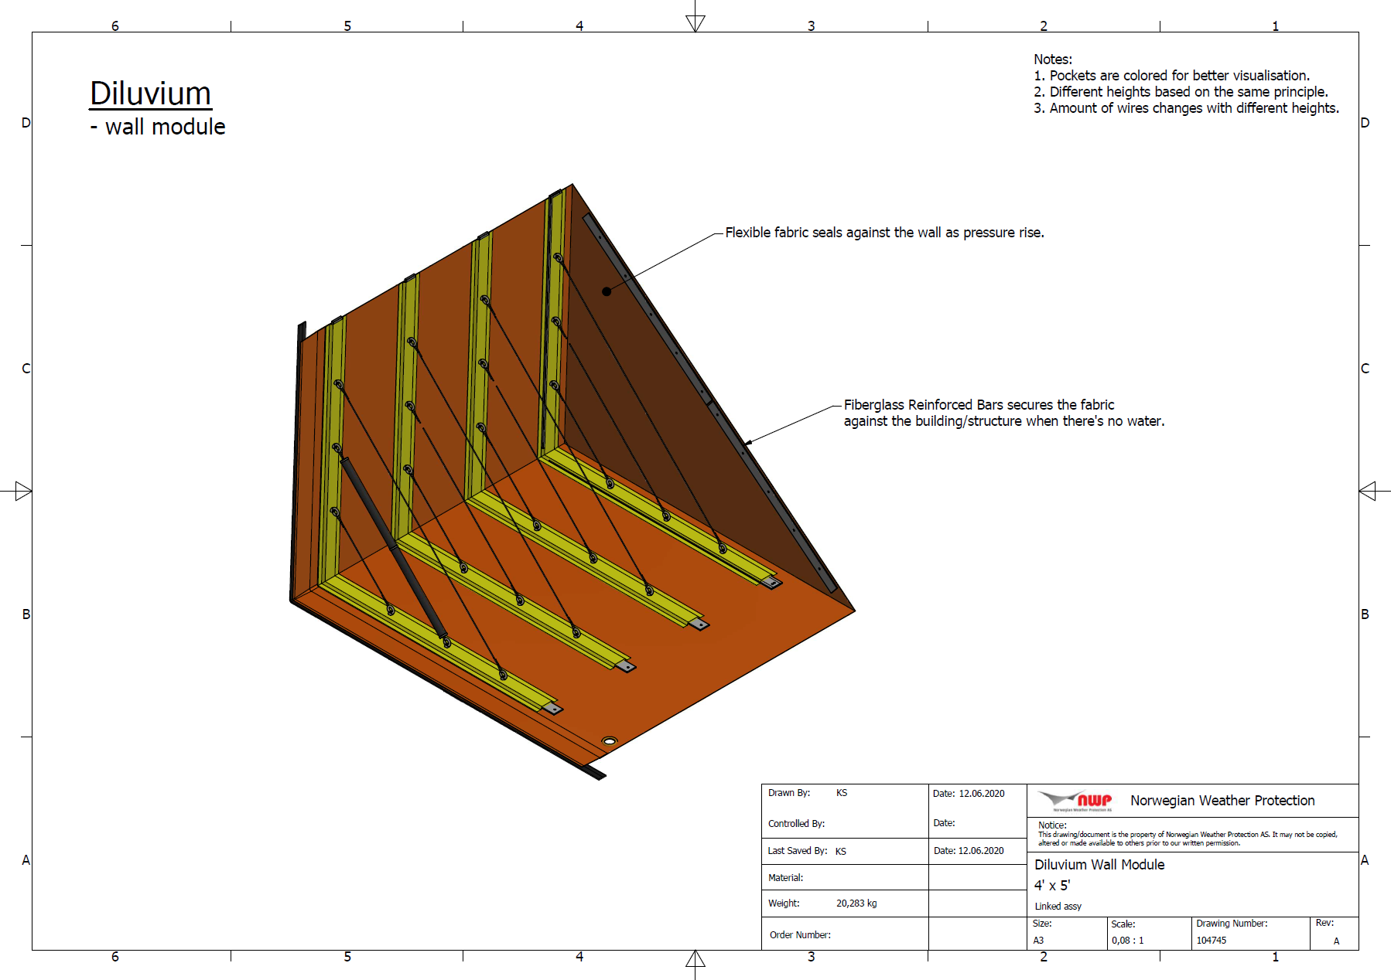

END OF SECTION

Please feel free to copy and paste the below graphic to your plans.
