INPRO-71300

flex-wall™ (VERTICALLY Deployed)

Operations & Maintenance Manual
Version – Initial Release
Date: 9/22/2016

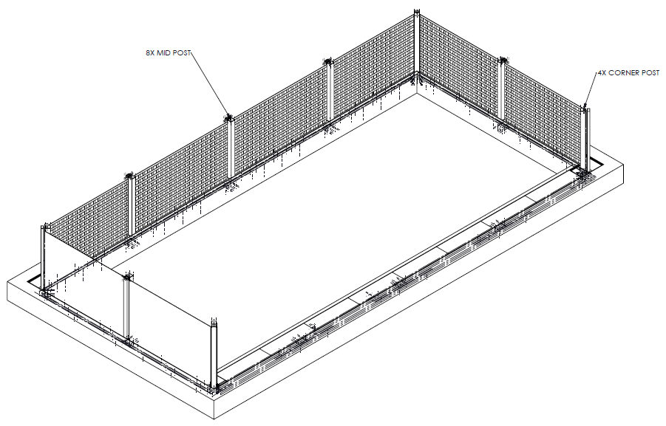

ILC Dover LP – One Moonwalker Rd. Frederica, DE 19946 - www.ilcdover.com

VERSION HISTORY

Version # | Revision  Date | Reason
IR | 9-22-16 | Initial Release

General information
In these operating instructions, this symbol indicates points of particular importance to safety. The instructions at these points must always be observed in order to avoid the risk of serious injury.

TABLE OF CONTENTS
1 introduction 4
2 System Description 4
3 Flex-Wall™ Operation 8
3.1 Flex-Wall™ deployment 8
3.2 Flex-Wall™ stowing 10
4 Flex-Wall™ Maintenance 11
5 Service Information 12
6 Warranty 13
7 Contact Information 13

introduction
This document, the ‘Flex-Wall™ (Vertically Deployed) Operations and Maintenance Manual’, provides the information and procedures required for the proper storage, deployment, stowing, inspection and maintenance of installed Vertically Deployed Flex-Wall™ flood mitigation systems.

System Description
The Vertically Deployed Flex-Wall™ is a high strength water-tight fabric wall that can be deployed rapidly for flood protection around/between buildings, across doors of any size, or in front of glass walls. It can be scaled to withstand any water height, and can be shaped to fit around any structure including corners of any angle. It is stored in a covered trench at the point of use so that all materials and components are available when needed. The Flex-Wall™ is simple to operate and can be easily deployed or stowed by a single person within minutes, even in high winds. The Flex-Wall™ can surround entire spaces (buildings), or span openings and seal against existing walls (doors, driveways, etc.).
The system is manually reconfigured to transition between the stowed and deployed configurations. When stowed, the Vertically Deployed Flex-Wall™ system is an unobtrusive part of the surrounding infrastructure as it is typically stored in a trench below grade. The Vertically Deployed Flex-Wall™ system can also be stored in knee-walls, door frames, window sills, and other methods.
The Vertically Deployed Flex-Wall™ is able to be adapted to many different use configurations but typically exists in 2 basic configurations:
- Short wall with vertical posts
- Tall wall with braced posts
These Flex-Wall™ configurations facilitate protection of various building openings, closing spaces between buildings/walls, or surrounding areas for protection. The configurations utilize the same basic parts and attachments but are scaled to meet the needs of each installation.
Vertically Deployed Flex-Wall™ system major parts are:
- a strong, flexible multi-layer wall (coated fabric water barrier layer and textile webbing structural layer) that, when deployed, prevents the passage of water
- an extension of the multi-layered flexible wall that is attached to the bottom of the vertical flexible wall but lays flat against the ground, and contains a means of sealing to the ground with clamping plates and bolts
- a trench with cover plates that house the flexible wall, receivers, and posts when they are not in use
- a receiver that is anchored in the trench to become the holders for the posts
- building mounted receivers (inset anchored plates or drop-in anchors) and clamping plates that anchor and seal the vertical portions of the Flex-Wall to buildings or other structures
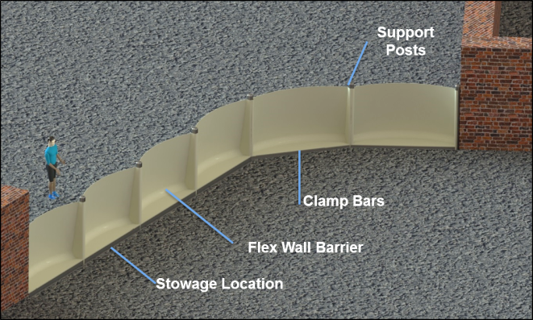
Flex-Wall System Components

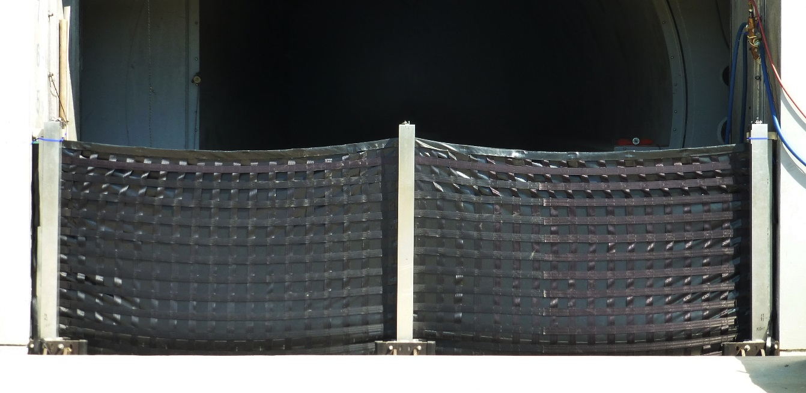
Flex-Wall System Deployed (from the dry side)

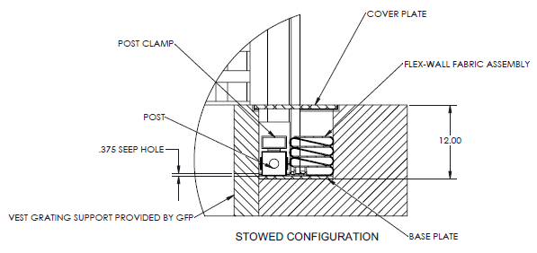
Flex-Wall System in Packed State

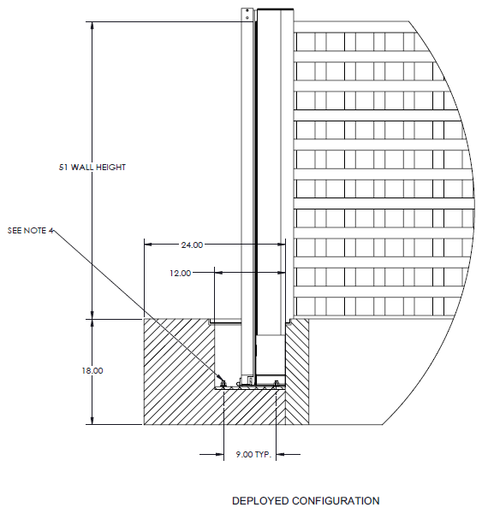
Flex-Wall System in Deployed State

Cautions
The following are precautions for the Flex-Wall™ system operation and maintenance. These are important to ensure the system operates as designed and personnel are not injured during the deployment or stowing of the system.
- Operation
  - We recommend the user and any other persons in the vicinity wear suitable eye protection, a hard hat, and protective gloves when deploying or retracting the Flex-Wall™.
  - Seepage – The Flex-Wall™ is designed to withstand flood water but will experience some seepage at its perimeter seals to the ground and building. The operator must consider some quantity of seepage and plan accordingly during the flooding event. The amount of seepage is dependent on building/grounds condition (cracks, scrapes), debris trapped in the opening during deployment (garbage, leaves, etc.), and proper deployment.
    - Seepage – up to 0.01GPM/ft of opening perimeter
    - Sump systems can be used to mitigate leakage. Ensure power (electric or battery back-up) will be available
  - Trip Hazards – The Flex-Wall trench and equipment should be avoided as a walking surface when the trench covers are removed or tripping may occur.
  - Impact Deflection – The Flex-Wall™ is designed to withstand impact from floating debris as specified for its installation location. It should be noted that debris impact can cause deflection in the wall and therefore the distance between the wall and the building/entrance must be considered to avoid imparting impact loads to the building/entrance.
- Deployment and Retraction
  - Lifting Hazards – Proper precautions must be taken when lifting parts of the Flex-Wall in order to avoid injury.
  - Pinch Hazards - Proper precautions must be taken when clamping plates, inserting posts into receivers, and other actions in order to avoid injury. Wearing work gloves is advised.
  - Wind Effects - Proper precautions must be taken when deploying the Flex-Wall in wind in order to avoid injury. Care must be taken to avoid standing in locations where the wall catch wind swing.

Flex-Wall™ Operation

Flex-Wall™ deployment
These steps are for reconfiguring a Vertically Deployed Flex-Wall™ from a closed trench/container to a deployed system.

STEP 1. Release the cover plates from the trench by unbolting them (if required). Lift the covers off and place them on the dry side of the trench.
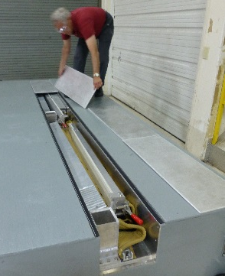
Figure 1 – Removing the cover plates from the Flex-Wall trench

STEP 2. Lift the posts from the trench and insert them into the receivers. Note: The posts may have clips on them for attaching the flexible walls. The clip side of the post should be on the flexible wall side.
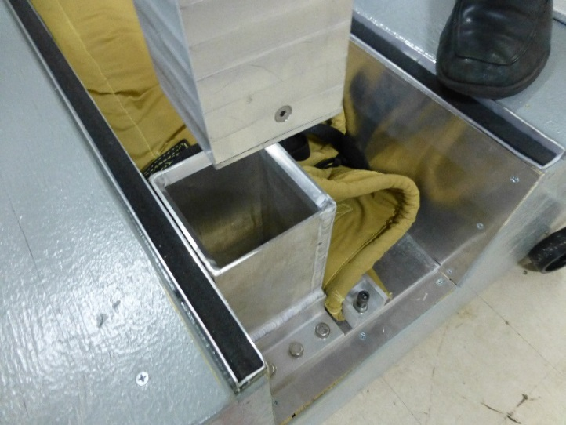
Figure 2 – Lifting the posts from the trench and inserting them into the receivers
STEP 3. Lift the flexible wall from the trench and connect the hooks to the posts. If the wall is tall (>4ft), intermediate attachment points will be included on the post and flexible wall to facilitate an incremental raising of the flexible wall. This can be used to negate the effects of wind trying to push the wall if deploying in strong winds. Note: The flexible wall is permanently attached to the bottom of the trench. Do not loosen these bolts.
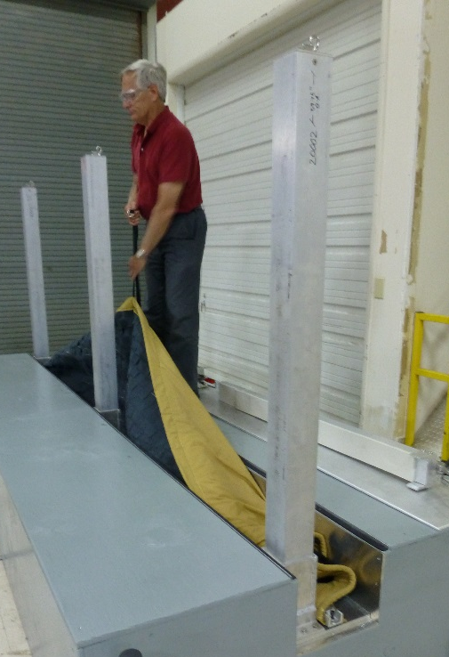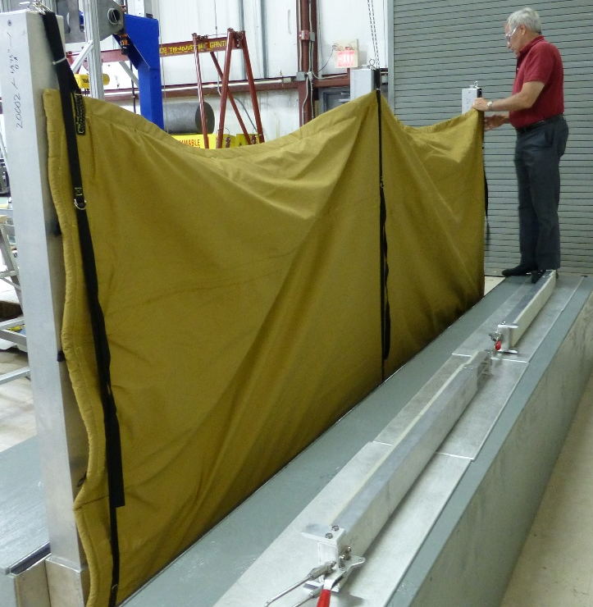
Figure 2 – Lifting and attaching the flexible wall to the posts

STEP 4A. [Flex-Wall to Flex-Wall™ Connection] Connect the ends of the Flex-Wall™ to the next section of Flex-Wall™. Remove pre-installed clamping plates and bolts from the post and receiver by unbolting them, or retrieve them from the trench. The walls will be overlapped with a gasket seal between them. Place the clamping plates over the flexible wall sections and bolt them to the post and receiver. Tighten the bolts to 38 ft-lbs torque for ½ in bolts.
WARNING: The gasket must be between the flexible wall sections or leakage will occur.

STEP 4B. [Flex-Wall™ to Building Connection] Connect the ends of the Flex-Wall™ to the wall’s termination point such as a building. If the building has a protective cover over the wall attachment location, then open/remove it. Remove pre-installed clamping plates and bolts from the building and end wall of the trench by unbolting them, or retrieve them from the trench. Lift the wall and position the it over the anchor points in the building. The gasket seal on the wall must be between the building and the flexible wall. Place the clamping plates over the flexible wall sections and bolt them to the building and end wall of the trench. Tighten the bolts to 17-25 ft-lbs torque for 3/8in bolts.
WARNING: The gasket must be between the building and flexible wall or leakage will occur.

STEP 5. Inspect the Flex-Wall™ to verify no gaps exist on the sealing surfaces and the wall is properly installed.

Flex-Wall™ stowing
These steps are for reconfiguring a Vertically Deployed Flex-Wall™ from a deployed configuration to a stowed system. The user can determine if they want to stow the Flex-Wall™ immediately to reopen the facility, or if they want to clean and stow the Flex-Wall™ for future use. It is possible to stow the wall and reopen it for cleaning and re-stowing at a later date (night or weekend cleaning). The Flex-Wall™ should be cleaned as soon as possible to eliminate biological growth such as mold or fungus. Cleaning is only required if the Flex-Wall™ becomes exposed to water which might carry biologic matter (river water, seawater, storm water, etc.)

STEP 1A. [Flex-Wall to Building Connection] Unbolt the clamping plates from the building and end wall of the trench. Remove the flexible wall from the building and fold it away from the building. Return the clamping plates and bolts to their stowed position in the trench or on the building. Reattach protective cover over the wall connection location (if necessary).
STEP 1B. [Flex-Wall™ to Flex-Wall™ Connection] Unbolt the clamping plates from the post and receiver. Remove the flexible wall from the post and fold it away from the post. Return the clamping plates and bolts to their stowed position on the post and receiver or in the trench.

STEP 2. Unhook the flexible wall from the posts and position it on the ground away from the posts.
WARNING: Do not walk on the flexible wall as it could damage the wall and may be slippery when wet and cause a fall, or be a tripping hazard.

STEP 3. Remove the posts from the receivers and lay them in the trench between the receivers.

STEP 4. Fold the flexible wall into the trench. “Z-folding”, or layering the material is the most efficient packing method. Rolling is also possible. Random bunching of the material should be avoided as this may make it difficult to put the covers on the trench.

STEP 5. Place the covers back on the trench. Lock them in place as required.
WARNING: If the trench covers can’t be closed because the material is preventing closure, return to step 4 and repack the flexible wall so it fits better.

Flex-Wall™ Maintenance
The following is a description of general maintenance required for the Vertically Deployed Flex-Wall™. Frequency of maintenance is at the discretion of the owner but ILC recommends that inspections be performed yearly (in some cases this is by code), and maintenance be performed at those inspections as required.

Mechanical Equipment:
- Operation: Inspect and lubricate rotating surfaces, then verify good working order.
  - Trench covers.
  - Bolts, nuts, and covers [Clamping Plate Systems].
Gaskets and Flexible Materials:
- Operation: Inspect and repair damaged components as necessary.
  - Flexible wall to building gaskets.
  - Coated Fabric component of the Flex-Wall™ – look for holes or cuts. Notify ILC Dover to arrange repair if necessary.
Site Location:
- Operation: Inspect and repair building & ground surfaces
  - Building to Flex-Wall interface – look for cracks in the building and fill any that are found.
  - Bottom of the trench where the Flex-Wall™ is anchored with clamping plates – look for cracks and fill any that are found.

Cleaning after a storm is critical to maintaining longevity of the system. All biologic matter must be removed to prevent mold and fungus growth. The Flex-Wall™ can be stowed wet immediately after a flood so the facility can be opened if desired. However, the system must be cleaned as soon as possible to limit growth. This enables work to be conducted on night or weekend shifts. The following steps should be taken after exposure to flood water (river water, seawater, run-off, etc.):
- Deploy the system
- Spray the system with an environmentally friendly soap and water solution
- Rinse the system to remove soap. Power wash if necessary.
- Allow the system to dry
- Repack the system

Service Information
As a guideline, the Vertically Deployed Flex-Wall™ is capable of 75 years of operation with proper routine maintenance and refurbishment of the flexible materials at planned intervals. Refurbishment intervals are dependent on operational use and environmental conditions. The limiting elements of any flood protection system are the elastomeric components (seals and coated fabrics). Our systems are designed to use the longest life materials available and protect these materials from environmental exposure when not in use.
We anticipate that the flexible components of the system will need to be replaced at 20-25 year intervals. ILC Dover will perform this service. No replacement of metallic components is anticipated for the life of the product.

Other fee-based services ILC can perform include:
- inspection of the Flex-Walls™ to aid in the assessment of materials life
- component replacement
- system test and evaluation
- operator training
- spare parts (extra parts to have on hand in case something is damaged or lost during training or operation)

Warranty
Seller warrants to Buyer that the Goods at the time of shipment to Buyer hereunder, (a) will conform to the specifications of the order; (b) that it will convey good title thereto and that such Goods will be delivered free from any lawful security interest or other lien or encumbrance unknown to Buyer; and (c) that such Goods will be free from defects in material and workmanship. The warranty shall begin upon final acceptance and shall extend for a period of one (1) year. The warranty is contingent upon performance of servicing and maintenance of the deliverable as specified in the maintenance plan. If nonconforming work is identified within the warranty period, Buyer shall promptly notify Seller in writing and Seller, at Buyer’s option, shall promptly repair or replace the defective goods.

Notwithstanding any other provision contained herein or any other obligation of Buyer hereunder, Buyer, upon acceptance of Goods that are the subject of the Order, warrants that Buyer, its successors, assigns, agents and employees are industrial users of such Goods and possess the knowledge and expertise to use the same in accordance with (i) accepted industry standards, (ii) all applicable laws, (iii) prudent safety practices and (iv) operating manuals or other instructions provided by Seller, if any.

Contact Information
ILC Dover
One Moonwalker Road
Frederica, Delaware 19946
Sales & Customer Service:
1-302-335-3911 x 506 or
1-800-631-9567 (US Toll Free)
Email: customer_service@ilcdover.com
See more at: http://www.ilcdover.com

